WATER MANAGEMENT SYSTEM USING ARDUINO

|  |  |  |
| --- | --- | --- |
| R.Sumathy Department of ECE Kalasalingam Academy of Research and EducationKrishnankoil, India rsumathy@klu.ac.in | A. Hemanth Kumar Department of CSE Kalasalingam Academy of Research and EducationKrishnankoil, India hemanthkumar312004@gmail.com | G.Sarveswar Raj Department of CSE Kalasalingam Academy of Research and EducationKrishnankoil, India gummadisarves2004@gmail.com |
| D.Rohith kumar reddy Department of CSE Kalasalingam Academy of Research and EducationKrishnankoil, India rohithkumarreddy9999@gmail.com | M.Venkata RaviKumar Department of CSE Kalasalingam Academy of Research and EducationKrishnankoil, India mvravikumar6301@gmail.com | N.Naveen Reddy Department of CSE Kalasalingam Academy of Research and EducationKrishnankoil, India narunaveen48@gmail.com |

***Abstract: The importance of water management is recognized in various places like societies, schools, universities, hostels, etc. A person is needed to handle water responsibilities. If water management is neglected or the person is not available, people may face water shortages or wastage issues. To address these concerns, a water management system is suggested. It has both automatic and manual modes. The tank is automatically refilled in the automatic mode when the water level is low. The manual mode allows manual control of water levels. LED lights are used to indicate the water level, and the system includes error detection capabilities.***

I.INTRODUCTION

Water level data and changes in water level are detected by sensors at specific intervals. A water management system is created using an ultrasonic sensor to sense the water level. In automatic mode, the system decides to turn the motor on or off. If the water level is below the specified level, the motor turns on to fill the tank. Once the water depth reaches the maximum, the system automatically turns off.

If the device is in manual mode, the motor starts or stops based on manual instructions. Additionally, the system continuously monitors water level changes when the motor is on. If the water level doesn't increase, an Error mode is activated. No functions operate until the system is reset by pressing the reset button.

There will be the push buttons by which we can change the system from the manual node to automatic mode and also from the manual mode to the automatic mode.

There will be the physical reset button. By that we reset the system. If the system goes to the error mode.

The error mode is entered by the system if there is any problem with the motor. Also, when the motor is on, the level of water is monitored. If the water depth does not increase after a certain interval of time, the error mode is triggered. The reasons for this could involve issues with the external voltage supply to the motor, problems with the external water source to the motor, or malfunctions with the motor.

II. LITERATURE SURVEY

[1] This research paper proposes a smart water management system utilizing Arduino and IoT for rainwater harvesting and efficient usage. The design incorporates ultrasonic sensors to monitor water levels in tanks, with data transmitted to a smartphone app. The system controls a water pump based on tank levels and irrigates the garden using a soil moisture sensor. Emphasizing the benefits of rainwater harvesting, the study underscores reduced surface runoff and erosion. The hardware includes NodeMCU, ultrasonic sensors, solar panels, and soil moisture sensors, with Blynk app enabling remote control. The research concludes by highlighting the significance of smart water management in addressing environmental challenges and contributing to sustainable practices. The future scope suggests broader applications in smart city initiatives and improved service levels. Overall, the study underscores the role of IoT in advancing water management for a more sustainable future.

[2] This research paper explores the application of Internet of Things (IoT) technology for water management in educational institutions, buildings, and commercial areas. The proposed system employs IoT devices, including ultrasonic sensors for water level detection, water flow sensors for monitoring usage, and temperature sensors for real-time temperature assessment. The automated system, controlled by an Arduino Uno microcontroller and integrated with Wi-Fi and GSM modules, aims to prevent water overflow and regulate usage efficiently. The study emphasizes the advantages of reducing water wastage, providing real-time information, and being cost-effective. Additionally, suggestions are made to enhance the system by incorporating turbidity and pH sensors for water quality monitoring. Overall, the research advocates for an IoT-based solution to optimize water management and promote sustainability.

III. PROPOSED SYSTEM

In the proposed water management system using Arduino is designed to make handling water easier in places like homes, schools, and societies. It has two modes – automatic and manual. An ultrasonic sensor keeps an eye on the water level. In automatic mode, the system starts the water pump when the water is low and stops it when it's full. In manual mode, you can control the pump yourself. LED lights show the water level, and the system can detect errors. This system helps manage water more efficiently, finds problems, and saves costs. The system's decision-making process is illustrated through the presented flowchart.(as shown in fig1).

[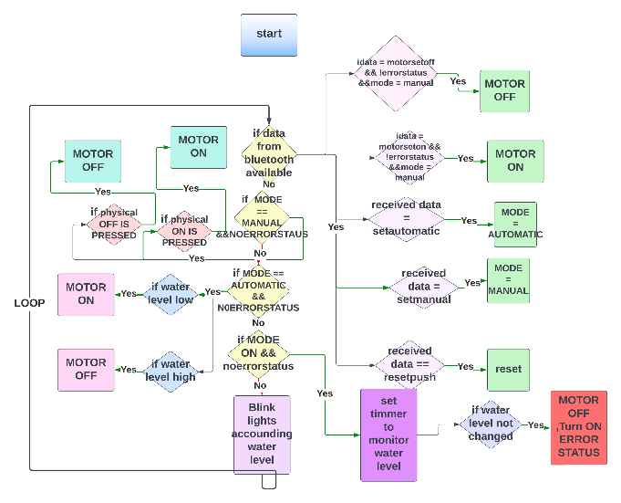](https://lucid.app/lucidchart/a96150e9-eb7e-4541-ada4-caf6e9f5260b/edit?crop=content&page=0&signature=72a0cba55156bd36f73979608c95bc5ef4227d51867e810ce3276b1e6a82e208)

Fig 1. Flow Chart

IV.METHODOLOGY

The methodology for the system involves two primary operation modes: manual and automatic. In the automatic mode, the system autonomously manages the motor, activating it when the water level is low and deactivating it near maximum capacity. The manual mode, on the other hand, empowers users to manually control the motor based on their preferences. Water level is indicated through a three-level LED system, while the motor and problem status are communicated via dedicated indicators. The system also integrates mobile operations, allowing users to remotely control modes and receive water level data. The LED display provides a comprehensive visual representation of the system's status. Overall, this methodology ensures a versatile and user-friendly water management system with both automated and manual control options.

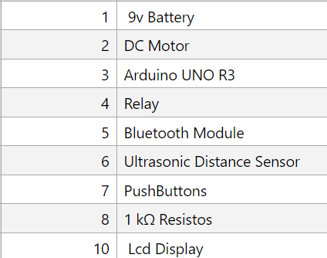

Fig 3**.** Components List

Ultrasonic Sensor:

The ultrasonic sensor helps measure water levels and track how quickly the water level rises when the motor is running. This information is sent to the Arduino, which then makes decisions based on it.

Bluetooth Module:

The Bluetooth module operates on a power supply ranging from about 3.8 volts to 5 volts. It consumes very little power. Bluetooth works in the 2.4 GHz band, providing secure communication between devices. The module has profiles that ensure secure data transfer between the system and a mobile phone. The Bluetooth module receives instructions from the mobile phone and sends them to the Arduino, allowing the system to be controlled wirelessly through a mobile phone.

Mobile Application:

The mobile application is built using Java in Android Studio. It connects to the system via Bluetooth and enables wireless communication. The app sends and receives data using the Bluetooth protocol, allowing users to operate the system through their mobile phones.to anticipate the following phrase using the context of the preceding words.

**[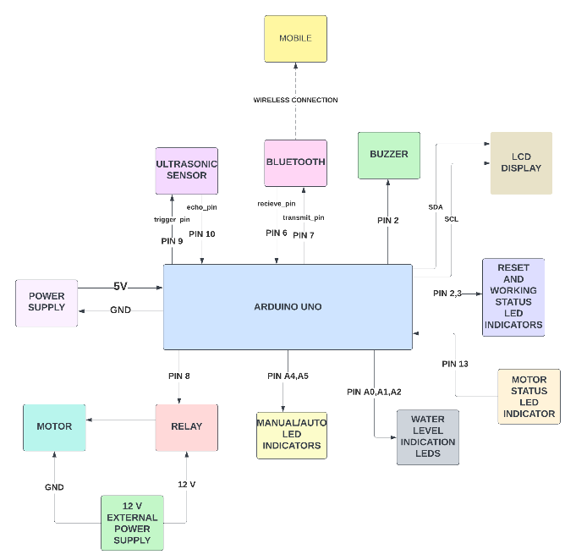](https://lucid.app/lucidchart/44d69a5f-6f5a-4079-9331-2189a16865d7/edit?crop=content&page=0&signature=26d077e65126db302c5381a61d1de182377f24bb259e53669c7622781d950f69)**

Fig 2**.** Block Diagram

V.EXPERIMENT AND IMPLEMENTATION

The circuit incorporates two Arduinos. The primary Arduino [(3 Arduino) in fig 3] manages the main functions, Bluetooth connections, and all LED indications. The second Arduino[(8 Arduino) in fig 3] is dedicated to overseeing the LED display.

Connections should be configured according to the provided connections below figure [3].

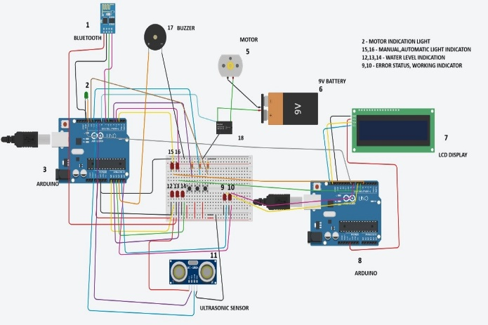

Fig 3**.** Circuit Diagram

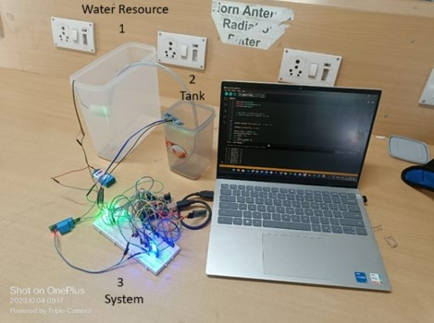

Fig 4. System Setup

I. Operation Modes

The system features two modes: manual (indicated by green) and automatic (indicated by blue) as shown in the below fig 4.

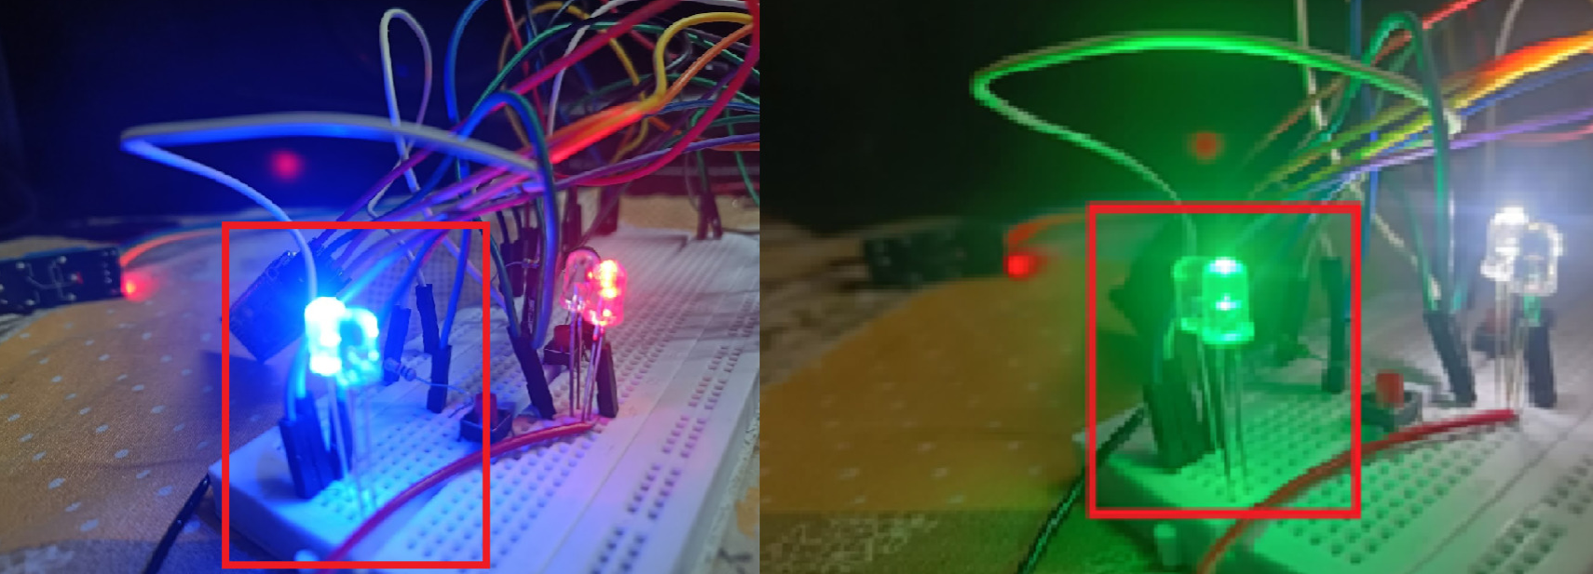

Fig 4**.** Manual and Auto

Automatic Mode:

The system initiates the motor when the water level is low, automatically turning it off as the water approaches maximum capacity. This cycle repeats whenever the water level decreases.

Manual Mode:

In manual mode (green), users have control over the motor, deciding when to activate or deactivate it based on their preferences.

II. Water Level Indicators

Three water level indicators are employe (12,13,14 as shown in fig[3]):

* One LED indicates low water level.
* Two LEDs indicate a medium water level.
* Three LEDs indicate a high water level.

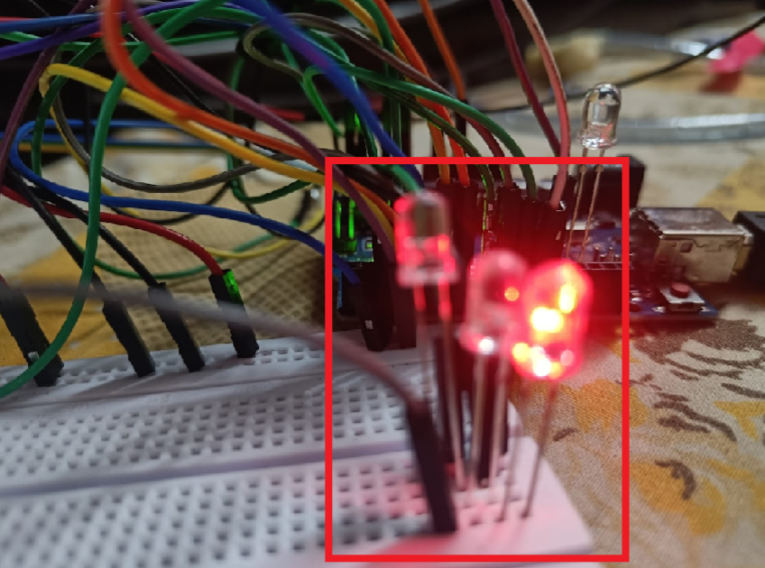

Fig 5**.** Manual and Automatic mode indicators

III. Motor Status Indicator

The LED reflects the motor status. It illuminates when the motor is on and turns off when the motor is inactive.

IV. Problem Status Indicator

White lights signify normal system operation.

In the presence of an issue, the system enters error mode, with a red LED and a buzzer providing an alert for attention.

V. Mobile Operations

The system can be remotely controlled via a mobile device.The device manager allows switching between manual and automatic modes.

In manual mode, users can manually control the motor's activation and deactivation.

A reset button is available to reset the device when in problem status mode.

Water level data is received through Bluetooth and displayed on the mobile device in a horizontal bar.

VI. LED Display Indication

The LED display conveys information on the mode, motor status, error mode, and Bluetooth connection.



Fig 3**.** LCD Display

V. RESULT AND DISCUSSION

The C++ code containing instructions based on data from the Ultrasonic sensor, Bluetooth module, and physical buttons is programmed into the Arduino. The decisions on what to do are made by the Arduino board based on the instructions received through the mobile and other inputs.

VI. CONCLUSION

A water management system can be introduced in residential homes, communities, schools, and other necessary locations to eliminate the need for an individual dedicated solely to water management. This implementation proves advantageous in efficiently handling and conserving water resources in these areas.

REFERENCES

[1]Vatsala Sharma Assistant Professor: Depart. of ECE BMIET, Sonipat, India. “Arduino based Smart Water Management” International Journal of Engineering Research&Technology Vol. 9 Issue 08, August-2020.

[2] Rama Krishna, SK Sajeeda, B Dhanya, M Meghana “Smart water management using IOT”, in International Journal of Advance Research and Innovation Volume 8 Issue 2 (2020) 172-174.

[3]Pratika Bhondve, Nikita Chaudhari, Saloni Thakur. IoT Based Water Management System Using Arduino. International Research Journal of Engineering and Technology . Volume: 06 Issue: 06 | June 2019

[4]S. K. Memon, F. K. Shaikh, N. A. Mahoto and A. A. Memon, "IoT based smart garbage monitoring & collection system using WeMos & Ultrasonic sensors", 2019 2nd International Conference.

[5]J Janet1, S Sureshkumar , A Riyaz Ahamed and R Kaviyaraj “Indicator for The Water Level Using Bluetooth ” . doi:10.1088/1742-6596/1916/1/012166

[6] Shifeng Fang, LiDaXu. An Integrated System for Regional Environmental Monitoring and Management Based on Internet of Things[J], IEEE TRANSACTIONS ON INDUSTRIAL INFORMATICS, VOL. 10, NO. 2, MAY 2014, PP:1596-1605.

[7] V.C. Sharath, S. Suhas, B.N. Sachin Jain, S.B. Vinay Kumar, C. Prasanna Kumar, “Smart aqua meter” in Advances in Electronics, Computers and Communications (ICAECC), 2014 International Conference on, October